**BU VR Project Guide**

Contents

Introduction 3

Project File Layout 3

Editable 3

Project 3

Scenes 4

Settings 5

VR 360 Setup 5

Tour Button Location 6

Tour Button Creation 6

Tour Button Adjustment 7

Tour Button Data Assignment 7

Potential Errors 8

Scene Data 8

Scene Data Creation 9

Scene Data Fields 10

Node Data 13

Node Data Fields 14

VR Game Setup 15

Game Controller 15

Game Controller Location 16

Game Controller Fields 16

Level Colours 19

# 

# Introduction

This guide will run through the steps required to edit, add, and build the project.

# Project File Layout

The project’s files are setup into 4 categories:

###### Figure : Project File Layout

## Editable

The “Editable” file contains changeable aspects of the project for the user to alter. It is recommended that users only edit and use elements from this section to avoid project malfunction.

###### Figure : Editable File Contents

## Project

The “Project” file contains the concrete functions for the project, these are aspects that are not editable for the user, it is recommended to avoid touching elements in this region unless the core system requires changing.

###### Figure : Project File Contents

## Scenes

The “Scenes” file contains the project’s scenes, the user can switch the loaded scene within the editor by double clicking their desired one. This will allow access to all the game objects associated with the scene, this is recommended if the user wishes to change a particular UI aspect or rearrange other objects within the scene.

###### Figure : Scenes File Contents

## Settings

The “Settings” file contains scene rendering and shading data, this area is best to avoid entirely, as it is created automatically from the project scenes.

###### Figure : Settings File Contents

# VR 360 Setup

The VR 360 system is constructed by three components:

* Tour Button(s)
* Scene Data
* Node Data

Most of the system is self-constructive, the only input required by the user is information for the “Scene” and “Node” data fields and the placement for “Tour Buttons”. Its important to note “Tour Buttons” require “Scene Data” to function properly, while “Node Data” requires “Scene Data” to exist.  
  
Tour Button  
The “Tour Button” is responsible for loading its assigned scene (“Scene Data”) when pressed.

The “Tour Button” is categorised as a “prefab” indicated by a blue cube icon, this infers it is universal in design and function.

It’s important to never modify the prefab version of the “Tour Button” found under the “Prefabs” folder, only modify a “Tour Button” when it’s within the scene, this is because all “Tour Buttons” within the scene are instances of the parent (the “Tour Button” under the “Prefabs” folder), by changing the parent you change all children causing all buttons to load the same scene, instead change the children (all scene “Tour Buttons”) as they retain individuality.

### Tour Button Location

Editable -> Prefabs

###### Figure : Tour Button Location

### Tour Button Creation

1. Click and drag the “Tour Button” prefab from the “Prefabs” folder into the hierarchy of the scene under the game object named “[Tour UI]” (this is recommended as all UI elements are interactable when under the “Canvas” game object, in this case the “[Tour UI]” is a child of the “Canvas”, thus carries the same properties).

Or

1. Copy and paste an existing button within the scene.

###### Figure : [Tour UI] Location

### Tour Button Adjustment

Button repositioning can be done by using the buttons located at the top left of the editor, it is recommended to only use the buttons highlighted in red, labelled “Move Tool”, “Rotate Tool”, “Scale Tool” and “Rect Tool” respectively. while the “Move Tool”, “Rotate Tool” and “Scale Tool” allows the object to be changed within the scene using their associated handles, the “Rect Tool” is only accessible when in “2D” mode. It is worth noting the toggle labelled “Global” or “Local” as this will determine whether the object will move based on its coordinates or the worlds.



###### Figure : Displacement Buttons

###### 

###### Figure : 2D Mode

### Tour Button Data Assignment

For the button to load the desired scene it requires the assignment of “Scene Data” found under the file:

* Editable -> Data -> Scene Data

Once the desired “Scene Data” is found click and drag it into the “Scene Data” field found in the inspector of the desired Tour Button found under:

* Tour Button -> Tour Button (Script) -> Scene Data

###### Figure : Tour Button Inspector

###### When the project is played the system will pull the data from the “Scene Data” assigned to the button to fill in its associated parameters, given the assigned “Scene Data” has values stated.

### Potential Errors

###### Any “Tour Button” within the scene with no “Scene Data” assigned will prevent the project from loading correctly, to resolve this issue either assign “Scene Data” to the “Tour Button” or delete the “Tour Button” in question from the scene.

###### Any “Tour Buttons” that have the same “Scene Data” assigned may cause the audio to become amplified for that scene, ensure all “Tour Buttons” have their own “Scene Data” attached.

## Scene Data

“Scene data” is a collection of information used to fill a scene when its associated button it pressed. “Scene Data” is editable, allowing the user to fill its contents with what they would like to see within the scene.   
  
Scene Data Location  
Editable -> Data -> Scene Data

###### Figure : Scene Data Location

### Scene Data Creation

1. Right click within the “Scene Data” folder -> Create -> Scene Data

Or

1. Copy and paste an existing “Scene Data”.

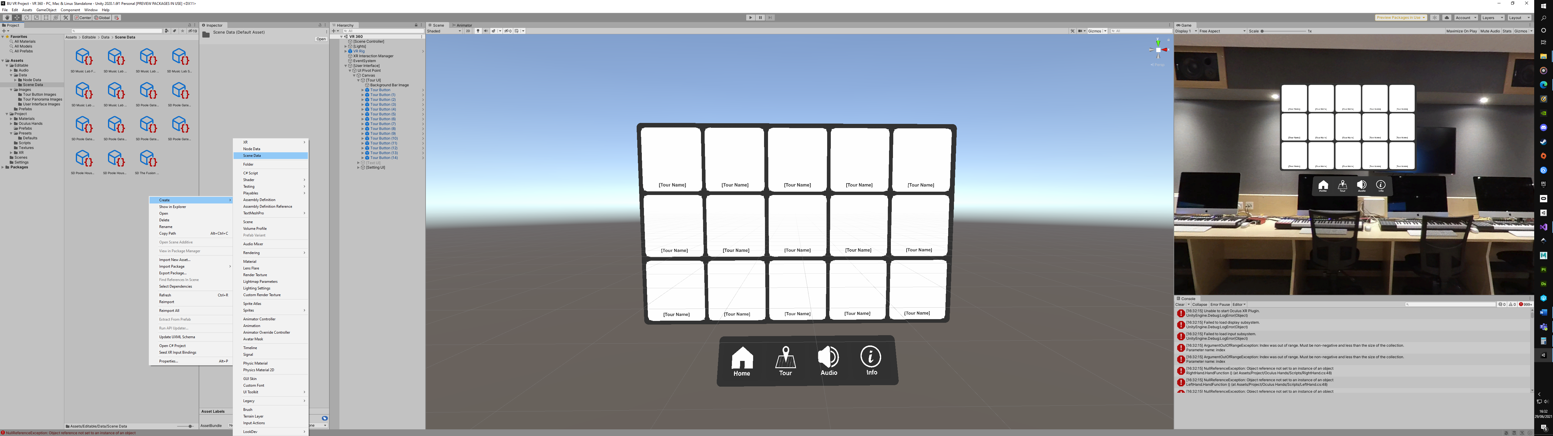

###### Figure : Scene Data Creation

### Scene Data Fields

###### Figure : Scene Data

#### Scene Name

The “Scene Name” field determines the “info” panel title.   
  
Scene Name Edit  
This field can be directly typed into.  
  
Scene Description  
The “Scene Description” field determines the “info” panel description.   
  
Scene Description Edit  
This field can be directly typed into.  
  
Scene Button Image  
The “Scene Button Image” determines the image on the “Tour Button”, currently the button images are set to 2356px x 2518px (Ratio of 1.068 to 1).   
  
Scene Button Image Location   
Editable -> Images -> Tour Button Images  
  
Scene Button Image Edit  
To assign this field click and drag the desired image from the “Tour Button Images” folder into the “Scene Button Image” field.

To assign an outside image to the field first drag the desired image into the “Tour Button Images” folder, this will import the image into the editor, however the image will be using the texture type “Default”, which doesn’t fit the “Scene Data” field requirement of “Sprite”, to change this click on the dropdown box and select “Sprite (2D and UI)” followed by the apply button to confirm change, once this is done the image is ready to be used.

###### Figure : Scene Button Image Setup

#### Scene Panorama Image

The “Scene Panorama Image” determined the scene’s 360 skybox image.   
  
Scene Panorama Image Location  
Editable -> Images -> Tour Panorama Images  
  
Scene Panorama Image Edit  
To assign this field click and drag the desired image from the “Tour Panorama Images” folder into the “Scene Panorama Image” field.

To assign an outside image to the field first drag the desired image into the “Tour Panorama Images” folder, this will import the image into the editor, however the image will be using the texture type “Default”, which doesn’t fit the “Scene Data” field requirement of “Texture 2D”, to change this click on the dropdown box and select “Sprite (2D and UI)” and change the “Max Size” value to the highest possible, this is to allow the image to fully utilise its high resolution reducing the pixelated appearance of the image, follow this with the apply button to confirm change, once this is done the image is ready to be used.

###### Figure : Scene Panorama Image Setup

#### Scene Audio

The “Scene Audio” determines the audio played when the scene is loaded.  
  
Scene Audio Location  
Editable -> Audio -> Scene Audio  
  
Scene Audio Edit  
To assign this field click and drag the desired audio clip from the “Scene Audio” folder into the “Scene Audio” field.

To assign an outside audio clip to the field first drag the desired audio clip into the “Scene Audio” folder, this will import the audio clip into the editor, once this is done the audio clip is ready to be used.  
  
Node Data  
The “Node Data” determines the existence and context of any present “Node Data” within the scene.  
  
Node Data Location  
Editable -> Data -> Node Data  
  
Node Data Edit  
The “Node Data” field is constructed as an array, essentially by typing a number in the “size” parameter allows the user to assign the equivalent amount of “Node Data” to the field. However, for each element created by the number stated in the “size” parameter, must have a “Node Data” assigned, otherwise the project will malfunction.

To assign a “Node Data” to the field click and drag the desired “Node Data” from the “Node Data” folder into one of the elements created in the “Node Data” field.

###### Figure : Node Data Array

## Node Data

“Node data” is a collection of information used to fill a node within a scene. “Node Data” is editable, allowing the user to fill its contents with what they would like to see on the node.   
  
Node Data Location  
Editable -> Data -> Node Data  
  
Node Data Creation

1. Right click within the “Scene Data” folder -> Create -> Node Data

Or

1. Copy and paste an existing “Node Data”.

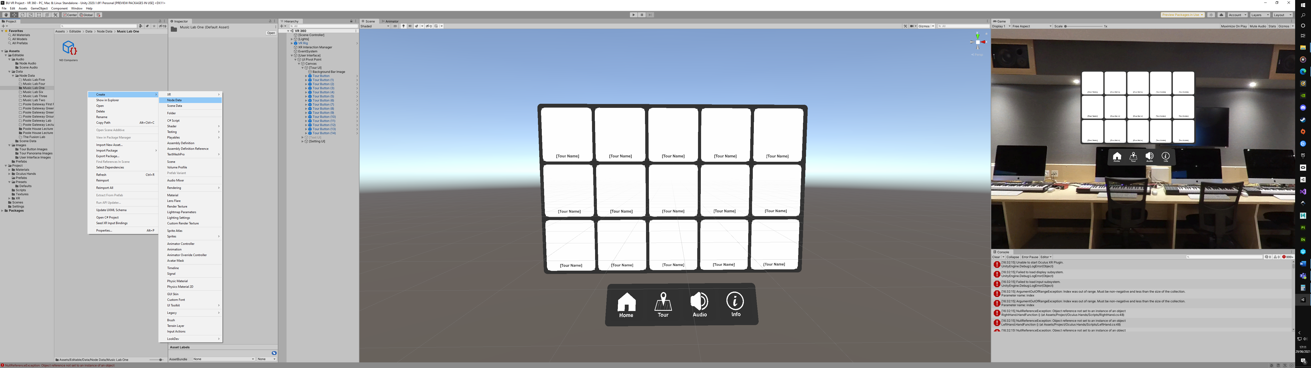

###### Figure : Node Data Creation

### Node Data Fields

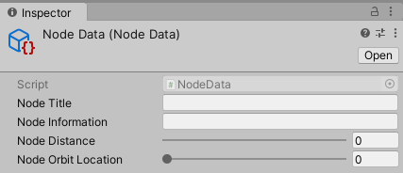

###### Figure : Node Data

#### Node Title

The “Node Title” field determines the title of the node.  
  
Node Title Edit  
This field can be directly typed into.  
  
Node Information  
The “Node Information” field determines what is shown for the node’s information.  
  
Node Information Edit  
This field can be directly typed into.  
  
Node Distance  
The “Node Distance” field determines how far away the node is from the user.  
  
Node Distance Edit  
This field can be directly typed into or by using the slider. It is advised to keep the value within the slider’s boundaries.  
  
Node Orbit Location  
The “Node Orbit Location” field determines the angle the node exists around the user.  
  
Node Orbit Location Edit  
This field can be directly typed into or by using the slider. It is advised to keep the value within the slider’s boundaries.

# VR Game Setup

## Game Controller

The game controller is responsible for most of the settings that the system uses to operate the game.

### Game Controller Location

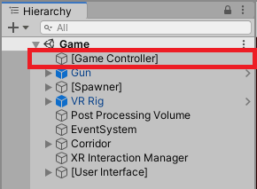

###### Figure : Game Controller Location

### Game Controller Fields

###### Figure : Game Controller Field

#### Square To Spawn

Determines the number of squares to spawn before game completion.

##### Square To Spawn Edit

This field can be directly typed into.  
  
Min Spawn Delay  
Minimum time before a square can be spawned.Min Spawn Delay Edit  
This field can be directly typed into.  
  
Max Spawn Delay  
Maximum time a square can be spawned.  
  
Max Spawn Delay Edit  
This field can be directly typed into.  
  
Colour Lerp Time  
Time it takes for the scene to transition to one colour to another.  
  
Colour Lerp Time Edit  
This field can be directly typed into.  
  
Level Speed  
This field is constructed as an array, with each element representing a level within the game. This field determines the speed of the rectangles and squares for each level.  
  
Level Speed Edit  
This field can be directly typed into.  
  
Level Required Score  
This field is constructed as an array, with each element representing the score required to process to the next level.  
  
Level Required Score Edit  
This field can be directly typed into.  
  
Level Colours  
This field is constructed as an array, with each element representing the scene colour for each level within the game.  
  
Level Colours Edit  
This field can be directly typed into.  
  
Square Audio Clip  
The “Square Audio Clip” determines the audio played when a square is hit by a projectile.  
  
Square Audio Clip Location  
Editable -> Audio -> Game Audio  
  
Square Audio Clip Edit  
To assign this field click and drag the desired audio clip from the “Game Audio” folder into the “Square Audio Clip” field.

To assign an outside audio clip to the field first drag the desired audio clip into the “Game Audio” folder, this will import the audio clip into the editor, once this is done the audio clip is ready to be used.  
  
Rectangle Audio Clip  
The “Rectangle Audio Clip” determines the audio played when a rectangle is hit by a projectile or the player.  
  
Rectangle Audio Clip Location  
Editable -> Audio -> Game Audio  
  
Rectangle Audio Clip Edit  
To assign this field click and drag the desired audio clip from the “Game Audio” folder into the “Rectangle Audio Clip” field.

To assign an outside audio clip to the field first drag the desired audio clip into the “Game Audio” folder, this will import the audio clip into the editor, once this is done the audio clip is ready to be used.  
  
AudioClip  
The “Audio Clip” determines the music played in the background.  
  
AudioClip Location  
Editable -> Audio -> Game Audio  
  
AudioClip Edit  
To assign this field click and drag the desired audio clip from the “Game Audio” folder into the “AudioClip” field.

To assign an outside audio clip to the field first drag the desired audio clip into the “Game Audio” folder, this will import the audio clip into the editor, once this is done the audio clip is ready to be used.  
  
Square Prefab  
The “Square Prefab” is the object spawned that the player can shoot to gain points.  
  
Square Prefab Location  
Editable -> Prefabs

Square Prefab Fields

###### Figure :Square Prefab Field

Level Colours  
This field is constructed as an array, with each element representing the colour the square takes for each level of the game.  
  
Level Colours Edit  
This field can be directly typed into.  
  
Level Images (One, Two & Three)  
This is constructed as an array, each element should contain an image that the system can randomly select upon spawn. Images in “Level One” will spawn in level one, images in “Level Two” will spawn in level two and images in “Level Three” will spawn in level three. It is recommended to use images that have a height and width ratio of 1:1.  
  
Level Images (One, Two & Three) Location   
Editable -> Images -> Icons  
  
Level Image (One, Two & Three) Edit  
To assign this field click and drag the desired image from the “Icons” folder into any of the three “Level Images” fields.

To assign an outside image to the field first drag the desired image into the “Icons” folder, this will import the image into the editor, however the image will be using the texture type “Default”, which doesn’t fit the field requirement of “Sprite”, to change this click on the dropdown box and select “Sprite (2D and UI)” followed by the apply button to confirm change, once this is done the image is ready to be used.

Figure : Scene Button Image Setup  
  
Rectangle Prefabs  
The “Rectangle Prefabs” are spawned to be dodged by the player.  
  
Rectangle Prefabs Location  
Editable -> Prefabs  
  
Rectangle Prefab Field

###### Figure : Rectangle Prefab Field

Rectangle Contact Score  
This field determines how many points are deducted from the score when the rectangle encounters the player.  
  
Rectangle Contact Score Edit  
This field can be directly typed into.  
  
Projectile Prefab  
The “Projectile Prefab” is spawned when the trigger fires the gun.  
  
Projectile Prefab Location  
Editable -> Prefab  
  
Projectile Prefab Field

###### Figure : Projectile Prefab Field

Projectile Speed  
This field determines the speed of the fired projectile. Its recommended not to exceed the value of 25 otherwise collision issues may be encountered.  
  
Projectile Speed Edit  
This field can be directly typed into.  
  
Square Score  
This field determines how many points are added to the score when a square is hit.  
  
Square Score Edit  
This field can be directly typed into.  
  
Rectangle Shot Score  
This field determines how many points are deducted from the score when a rectangle is hit by a projectile.  
  
Rectangle Shot Score Edit  
This field can be directly typed into.  
  
Build Project  
Once all the changes that the user desired have been made the final step it to create an executable version of the project.

This can be achieved through:

* File -> Build And Run

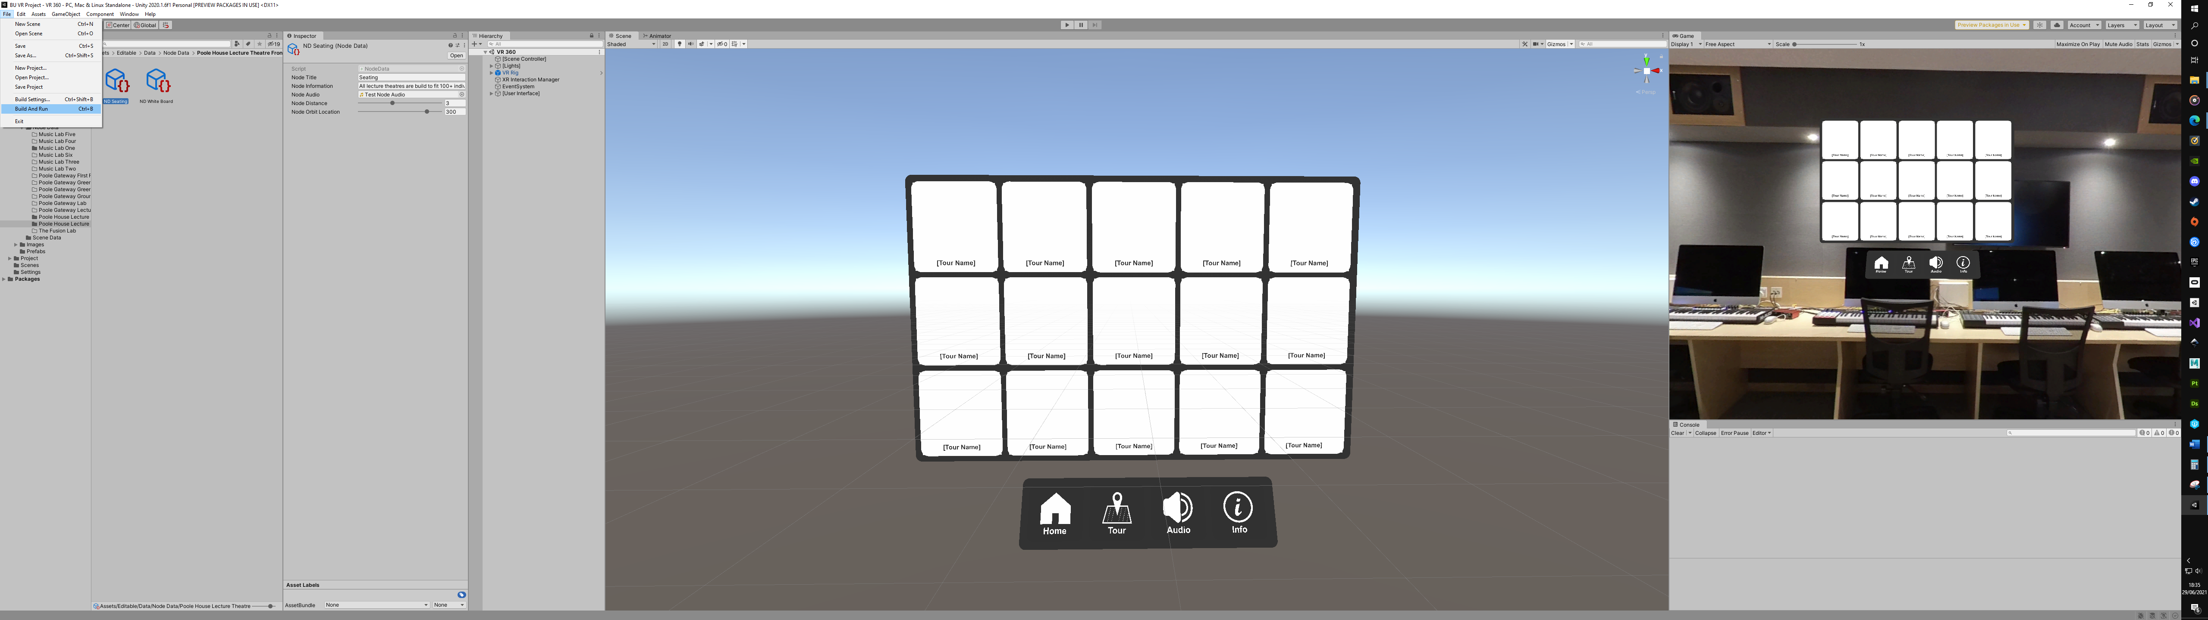

###### Figure : Build Project